Facebook Post
GIVEAWAY! We have some fantastic prizes for our loyal customers. To enter, tag a friend in the comments! Winners will be drawn and announced on Monday. UK only. This competition is also being run over on twitter, so enter there too to increase your chances! For full rules, see our website [blog link]
#christmas #mincepies #giveaway #freebies
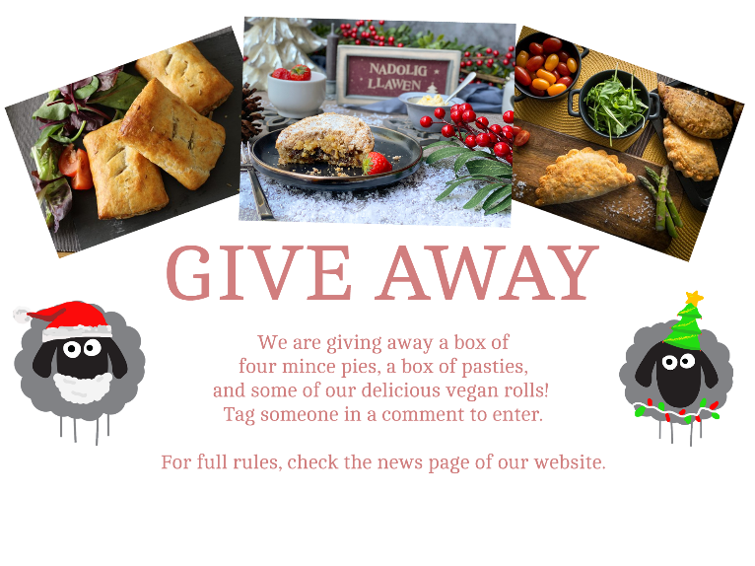

Twitter Post
GIVEAWAY! [emojis] Want to win some amazing products? To enter, @ a friend in the comments! Winner will be drawn from our twitter and Facebook comments on Monday. UK only. For full rules, see our website [blog link]
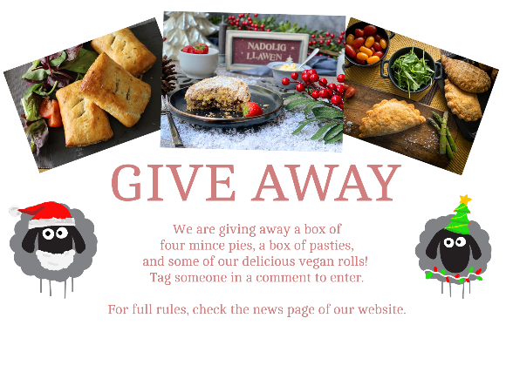

Blog Post

GIVEAWAY! We have some fantastic prizes for our loyal customers. Winners will be drawn and announced on Monday. The prizes are a box of 4 mince pies, a box of pasties, and some of our vegan rolls.
Now for the boring bit.
This giveaway is UK only. The winner will be announced across social media, and by entering you consent to us doing so. The winner will be contacted through a direct message on twitter or Facebook, so your inbox/direct messages MUST be open. If your inbox is not open a new winner will be chosen. You MUST to be able to provide us with an address to deliver to. If you cannot provide an address, a new winner will be chosen.
For a valid entry, you must tag a person in the comments of either the Twitter post or the Facebook post. You can enter on both websites, but only once per website. This is a single giveaway – there will not be a winner per website.
The winner will be drawn on Monday the 22nd of November, and announced across social media on the same day.
We reserve the right to cancel the giveaway at any time – but we probably won’t. We want you to enjoy these wonderful prizes!
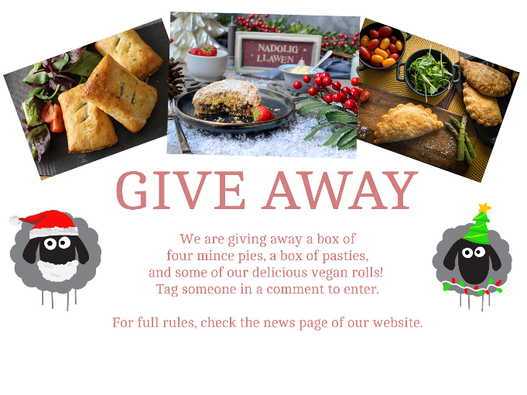
Thanks for reading. Find us on twitter @lewispies.

